Deanne Kroll
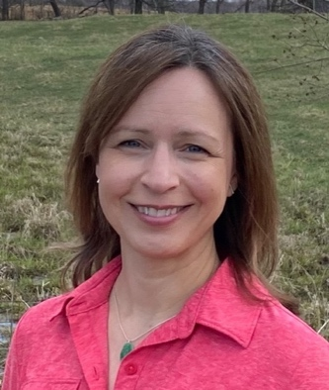

Creativity has spilled into all aspects of Deanne’s life since an early age, reflected in the many art classes she enrolled in Middle and High School, including at the Atelier Lack in Minneapolis. After graduating from High School, she became a full-time art student for 4 years at the Atelier LeSueur in Excelsior, Minnesota, under the mentorship of Steve Levine. Soon after she opened a studio in the Twin Cities where she painted various subjects including plein air, figure, still life and was teaching at the atelier of Minnesota River School of Art. It’s following a month-long trip to Olympic National Park, WA, that she decided to focus on plein air painting. Deanne has always felt a close connection with Nature, and Olympic lit a fire within her to share the immense beauty that is around us.

Kroll traveled extensively nationwide to plein air paint in Washington, Montana, Colorado, and North shore of Lake Superior, as well as internationally, in Italy – Florence and Venice –, and Switzerland. Master artists Sargent, Chardin, Sorolla and many contemporary landscape artists influence her the most and inspire her to show the magic that happens on the canvas when you are deeply connected to your subject.

Soon into her career, she experienced a health issue that led her to seek alternative methods of healing. Kroll’s journey included qigong and meditation which led her to become a Qigong Master Healer. This healing path now permeates into her artwork, giving it a more energetic presence.

She has taught classes and showed her artwork extensively in the Midwest, in galleries and privately. Among her numerous awards, most recently “The Best in Show” at the 2023 PAPNM Los Alamos Plein Air show, “Honorable Mention” at the PleinAir Salon in May 2022 and 2023, nominated in the November 2022 Top 100 Plein Air Salon, and PAPNM National Juried PleinAir Show 2022 and 2023, and PAPNM Fall Competition (2nd place 2021). She also won “Third Place” at the American Artist 60th anniversary art competition in 1997. Deanne is a member of the American Impressionist Society, National Oil & Acrylic Painters’ Society, Plein Air Painters of New Mexico, Plein Air Artists of Colorado, Oil Painters of America, and American Women Artists.

A native of the Chicago suburb and longtime Midwest resident, Deanne currently creates oil paintings on plein air locations and in her studio in Santa Fe, NM, where she moved to 3 years ago. The unique vibrant Southwest landscape and colors renewed her inspiration for the beauty surrounding us. Her art aims to evoke in the viewers a sense of wholeness and a reminder to connect more with self and nature.

